Confidential Business Synopsis

XYZ Fitness LLC.

This is a highly confidential business synopsis. Do not share this information with anyone.

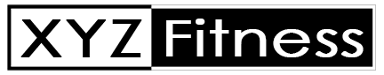
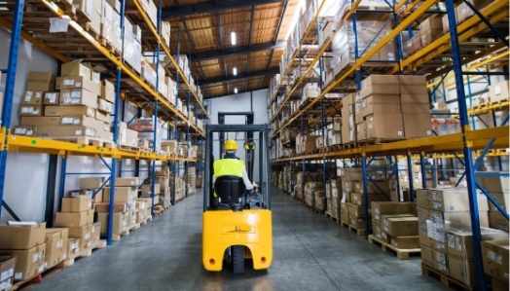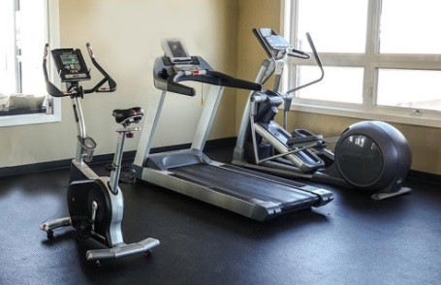
Listing Price: $1,500,000.00
Annual Sales: 2019- $1,700,000.00 Adjusted Profit: $400,000.00
2020- $1,400,000.00 $375,000.00
2021- $1,200,000.00 $250,000.00

Business Description-
Fitness has been servicing the home fitness industry through their online channels since 2012. XYZ Fitness holds IP for 6 different fitness products. In 2015, ABC was rated one of the top 20 online providers of at home fitness equipment. XYZ has built a 20,000 email customer base over the years that can be used for re-marketing and upselling. They also have a social media following of over 600,000 connections. XYZ manufactures their products overseas and handles the warehousing and shipping out of their 5,000 sq. ft. facility. XYZ continues to grow consistently form year to year.
Employees-
XYZ Fitness has 4 full-time and 3 part-time employees. 1- Office Manager. 1- Warehouse manager. 1- Marketing & Sales. 2- Full-time shipping & 2- Part-time shipping.
Year established-
XYZ Fitness was established in 2012. The BLANK owner purchased the business in 2017.
Reason for sale-
The owner is ready to retire.
Transition period-
I am willing to stay on for as long as it takes to foresee a smooth transition.
Included Assets-
Equipment Value: $5,000.00 Inventory Value: $25,000.00

Additional Information- Add any information that you feel will help a buyer get a better understanding of what your business is. REMEMBER: This synopsis is used for a basic teaser. Once you qualify the buyer, you will explain the details and continue to sell your business on a phone call, video conference or face to face with a buyer.

